W9 PRACTICE
QUIZ APP

 Important

- The reflection part will be done in teams of 2 (designing) and 4 (sharing)
- The coding part needs to be submitted individually

Learning objectives
- Handle navigation between multiple screens – Using a state (not router for now…)
- Pass data between screens
- Separate UI logic from business logic: using a model folder
- Reflect on the best approaches (data, states, widgets) to maintain a clean architecture

How to submit?
- Push your final code on your GitHub repository
- Then attach the GitHub path to the MS Team assignment and turn it in

Functional Requirements

For this practice (W9)
- The player can start the quiz and answer each question one by one
- Only single choice questions
- Once finished, the app shows the score and the questions results

For Bonus
- The history of the previous scores can be reviewed
- The quiz questions and player submission are persisted in JSON file

For next practice (W10)
- The player enters his/her name before starting
- It’s possible to edit the quiz questions

Non-Functional Requirements

- The application must implement the provided user flow and mockups

User Flow

For this practice, the following user flow/mockup are required:

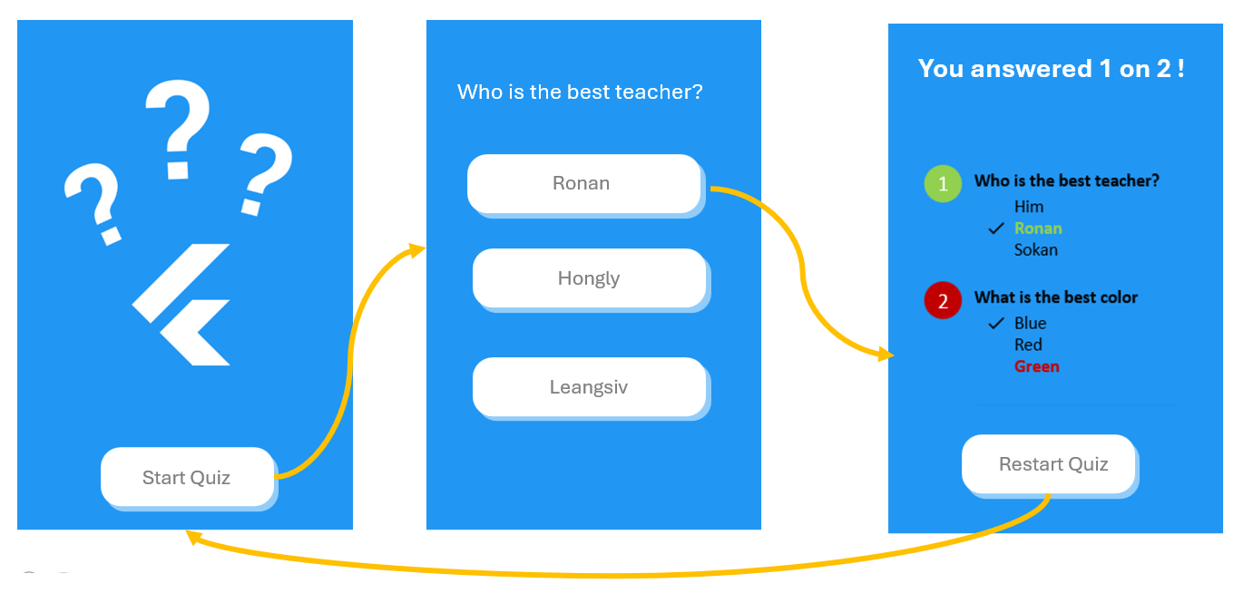

BONUS
To include the history of the previous scores, the user flow can evolve as follows:
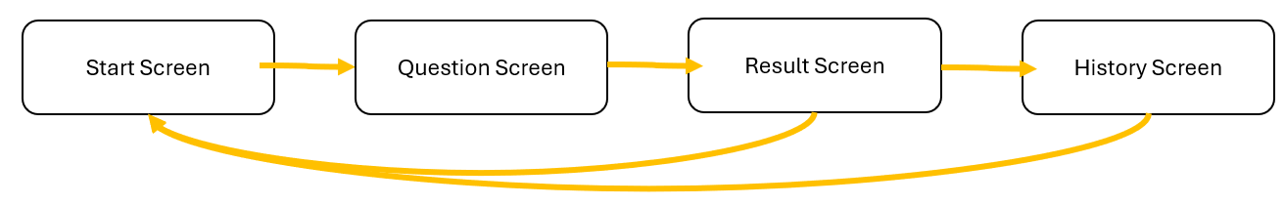

Layer structure
The application is structured around 3 layers: DATA > DOMAIN > UI

data | Repositories to load domain objects from data sources
model | Contain the domain classes
ui/screen | Screen widgets and sub-screen widgets
ui/widgets | Re usable widgets (button, inputs…)

Here is an example of project structure (just an example, not the correct one)

lib/
├─ data/
│ └─ repositories/
│ └─ quiz_json_repository.dart
│ └─ quiz_mock_repository.dart
├─ models/
│ └─ quiz.dart
│
└─ ui/
├─ screens/
│ └─ welcome_screen.dart
│ └─ question_screen.dart
└─ widgets/
└─ app_button.dart
└─ app_button.dart

main.dart

Layer interaction
- The main loads the quiz data (from mock data or from a Json file)
- The main create the quiz screen, passing the quiz data as parameter

PART 1 – REFLECTIONS

MODEL

To handle the functional requirements for this practice, and be ready for the next practice, how are you going to structure your model?

Q1 – Drop below the UML diagram of your model

{HERE}
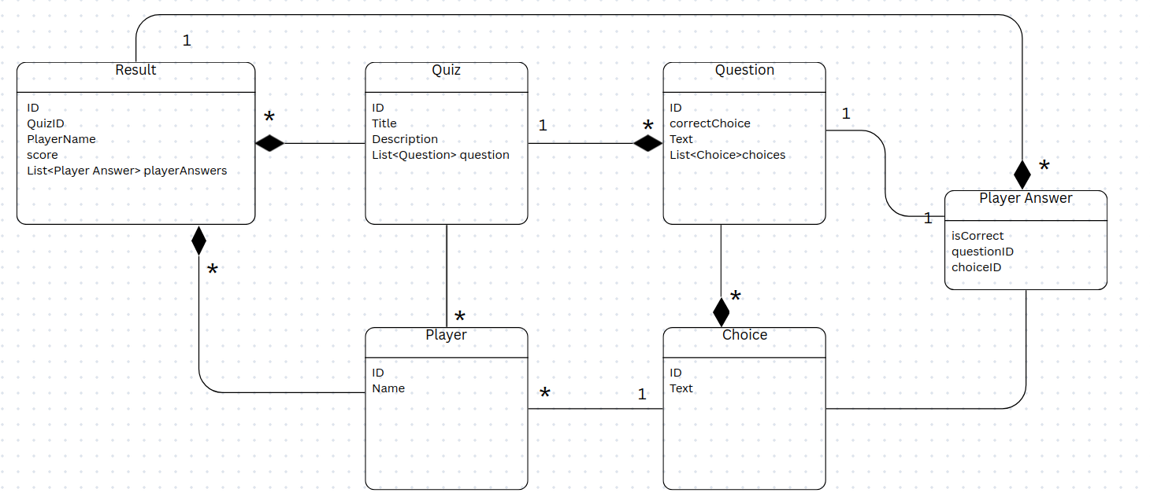

Q2 – Where do you keep player submission, so that you can display the last screen?

{HERE}

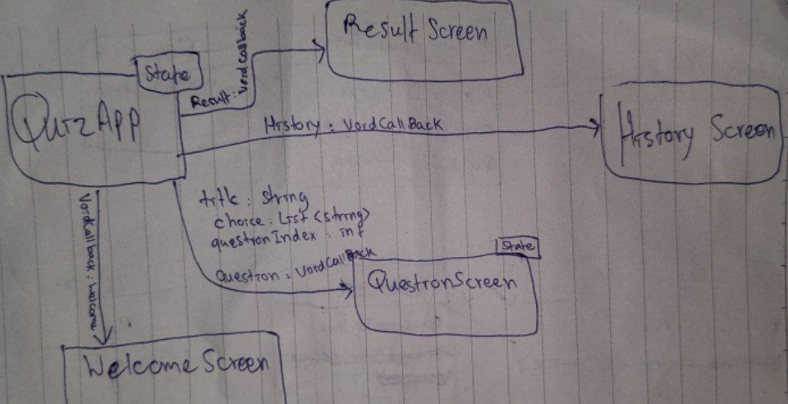

UI – Screens

We have 3 screens (start, question and result)

Q3 – Identify for each widget their properties

WIDGET | TYPE (SL / SF) | PARAMETERS | STATES
WelcomeScreen | Stateless | • onStartQuiz: VoidCallback  • onViewHistory: VoidCallback (Bonus) | None
QuizApp | Stateful | • quizData: Quiz  • repository: QuizRepository (for loading) | • _currentScreen: AppScreen  • _quizController: QuizController  • _currentResult: QuizResult?  • _history: List<QuizResult>
ResultScreen |  | • quizResult: QuizResult  • onRestart: VoidCallback  • onViewHistory: VoidCallback (Bonus)  • quizTitle: String (optional) | None
HistoryScreen | Stateful | • quizResults: List<QuizResult>  • onResultSelected: void Function(QuizResult)  • onBack: VoidCallback  • quizData: Map<String, Quiz> (for titles) | • _filteredResults: List<QuizResult>  • _sortOrder: SortOrder  • _selectedResult: QuizResult?
QuestionScreen | Stateful | • question: Question  • questionNumber: int  • totalQuestions: int  • onAnswerSelected: void Function(String choiceId)  • onNext: VoidCallback  • onFinish: VoidCallback  • isLastQuestion: bool | • _selectedChoiceId: String?  • _isSubmitted: bool  • _isLoading: bool (for async)

Q4 – Draw the COMPONENT DIAGRAM of the application

{HERE}

Q5 – Where and How do you manage the navigation to the next questions and to the last result screen?

{HERE}

UI – Reusable widget

List down the widget you are planning to re-use on different screens (button, card..)

WIDGET | TYPE (SL / SF) | PARAMETERS | STATES

PART 2 – IMPLEMENTATION

- The coding part needs to be submitted individually

HINTS

- Tip: you can divide each screen into many stateless screen-widgets, for example:

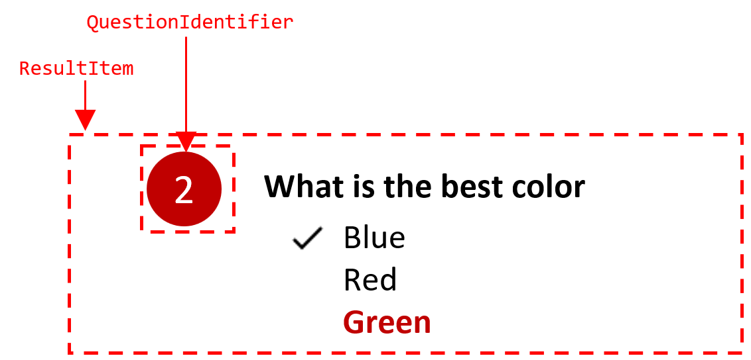

This widget takes as parameter a question and a player choice and handle the color computation, the choices highlighting etc..

